Methods
A phylogenetic tree was constructed from the Clustal Omega multiple sequence alignment using the neighbor-joining method with branch lengths representing substitutions per site, as computed by Clustal Omega (version 1.2.4). The resulting Newick-format tree was visualized using MEGA (version 11). Due to the limited dataset of four species, Maximum Likelihood inference and bootstrap resampling — as originally proposed — were not pursued, as these methods require larger datasets to produce reliable support values. Branch lengths were interpreted as a proxy for evolutionary rate, with longer branches indicating accelerated sequence divergence. The absence of guinea pig (Cavia porcellus) from the dataset, due to sequence unavailability, precluded the planned comparison of convergent pseudogenization events.

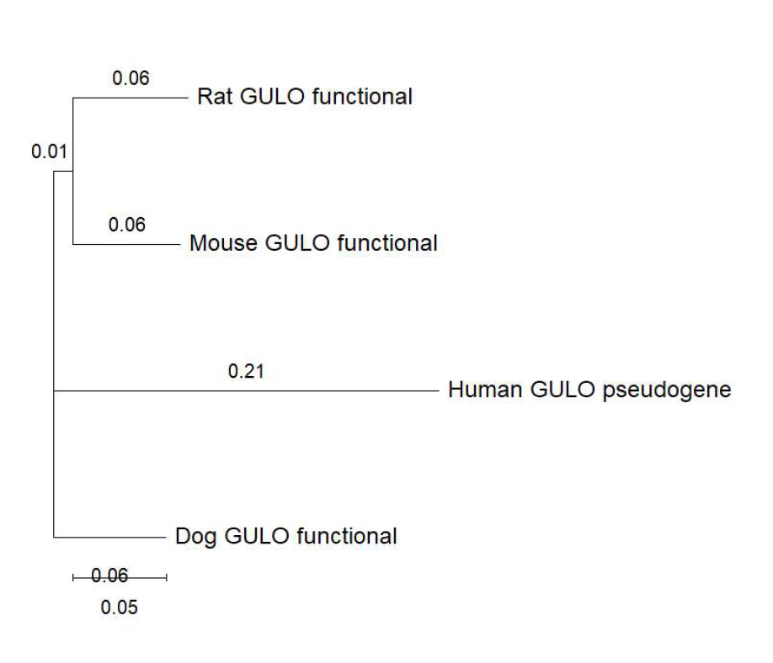
Phylogenetic tree of GULO nucleotide sequences across four mammalian species, constructed using the neighbor-joining method in Clustal Omega and visualized in MEGA 11. Branch lengths represent substitutions per site. The human GULO pseudogene (branch length = 0.21) shows markedly accelerated sequence divergence compared to functional orthologs (rat, mouse, dog; branch lengths = 0.06), consistent with relaxation of purifying selection following gene inactivation.

Results
The phylogenetic tree (tree.pdf, also above) revealed a topology consistent with established mammalian evolutionary relationships. Rat and mouse grouped as sister taxa connected by a short internal branch (0.01 substitutions per site), reflecting their shared rodent ancestry, while dog branched separately as expected for a carnivore. The human GULO pseudogene exhibited a branch length of 0.21 substitutions per site, approximately 3.5 times longer than any functional ortholog (rat: 0.06, mouse: 0.06, dog: 0.06). This pronounced elongation of the human branch is consistent with relaxation of purifying selection following gene inactivation: once the GULO gene lost its function, deleterious mutations were no longer selectively removed, allowing neutral mutations to accumulate at a higher rate. This finding at the nucleotide level corroborates the protein-level analysis performed in the companion alignment (Step 2, protein MSA), which identified complete disruption of the FAD-binding domain in the human pseudogene. Together, both analyses converge on the same conclusion: the human GULO locus has undergone extensive post-inactivation decay, retaining only remnant sequence similarity to functional orthologs.
Limitations
Several limitations should be noted. First, the phylogenetic tree was derived from a neighbor-joining algorithm rather than the Maximum Likelihood method originally proposed, as the small dataset of four sequences does not provide sufficient power for robust likelihood-based inference. Second, bootstrap support values were not calculated, meaning branch topology confidence cannot be formally assessed. Third, the absence of guinea pig (Cavia porcellus) from the dataset prevented the planned comparison of convergent independent GULO losses, which would have strengthened the evolutionary conclusions. Future analyses incorporating additional pseudogene-bearing species would provide a more complete picture of convergent GULO inactivation across mammals.

